Cloud Project report

ICTCLD401 – Configure cloud services

Travis Griggs

Travis.Griggs@student.tafesa.edu.au

001216363

Contents

1. Cloud Service Selection 2

Table of Cloud Service Selection 2

2. Implement Cloud User 2

2.1 Create all users and groups. 2

2.2 Test Login Users. 3

2.3 Configure group permissions. 3

2.4 Update AWS Password Policy. 3

2.5 Enable Multi-factor authentication. 3

2.6 Command-line access the cloud account. 3

3. Create AWS Virtual Network and Security settings 3

3.1 Configuration of multi-tiered virtual network 3

3.2 Create virtual machines: 4

3.3 Storage Configuration: 4

3.4 Database Configuration: 5

4. Auto-Scaling Configuration and Troubleshooting 5

4.1 Auto-Scaling Configuration 5

4.2 Troubleshooting Task 5

5. Documentation and seeking feedback 6

5.1 Troubleshooting Task 6

5.2 Seeking Feedback 6

Compose an email to the ITWorks manager. 6

6. Retrieved feedback and finish the additional task 6

# 1. Cloud Service Selection

## Table of Cloud Service Selection

|  |  |  |  |
| --- | --- | --- | --- |
| Cloud Services solution | Adopted option(s) | AWS Services Choice Recommendation | Justification |
| 1. Autoscaling Services: | Vertical scaling   Horizontal scaling | AWS Auto Scaling, Amazon EC2 | Horizontal scaling is chosen over vertical scaling because it allows for adding more instances instead of upgrading a single instance, which is more flexible and cost-effective. This is crucial for Erfys' requirement of high availability and scalability. |
| 1. Computing Services: | Virtual machines  Physical machines | Amazon EC2 | Virtual machines (VMs) are selected over physical machines because they offer greater flexibility, are easier to manage, and can be provisioned or decommissioned quickly, aligning with Erfys' need for rapid scalability and cost minimization. |
| 1. Storage Services: | Block storage  Object storage | Amazon S3 (Object Storage), Amazon EC2 Storage | S3 is well-suited for storing website content, backups, and organizational documents thanks to its scalability, durability, and built-in encryption. EC2 storage complements this by offering instance-level storage with block-level access, ideal for temporary data storage needs. |
| 1. Storage solutions: | Archive storage  Network filesystems storage | Amazon S3 Glacier, Amazon EFS | S3 Glacier fulfills long-term storage needs with affordable archival solutions, while EFS offers shared, active file storage across instances, allowing seamless access and updates to shared data. |
| 1. Database services: | Relational database  Data warehouse  No SQL databases | Amazon RDS (Relational Database Service) | Relational databases are ideal for structured data with defined relationships, fulfilling Erfys' need for transactional data management and scalability. |
| 1. Database solutions: | Self-hosted  Managed  Cloud-native | Amazon RDS | Managed databases reduce Erfys’ management burden while ensuring automatic backups, maintenance, and scaling, supporting their need for minimal in-house IT involvement. |

# 2. Implement Cloud User

## 2.1 Create all users and groups.

|  |  |  |
| --- | --- | --- |
| Username | Group Name | Policy Permissions |
| 001216363-Evan.Erfyl | 001216363-CEO | Full access to S3, EC2 and RDS services. |
| 001216363-Osacr. Erfyl | 001216363-SalesManager | Full access to S3 storage |
| 001216363-Hayley. Erfyl | 001216363-AdministrationManager | Read-only to S3 storage and EC2 instances |
| 001216363-Racheal.Amery | 001216363-RDManager | Read-only access to S3 storage and full access to EC2 instances. |
| 001216363-Lilian. Erfyl | 001216363-ProductionManager | Read-only access to S3 storage and full access to EC2 instances. |

*…screenshots of created users in the related groups…*

## 2.2 Test Login Users.

*…screenshots of login user CEO and Sales manager accounts …*

## 2.3 Configure group permissions.

*…screenshots of group policies assigned…*

## 2.4 Update AWS Password Policy.

*…screenshots of group policies assigned…*

## 2.5 Enable Multi-factor authentication.

*…screenshots of R&D manager user profile with multi-factor settings enabled…*

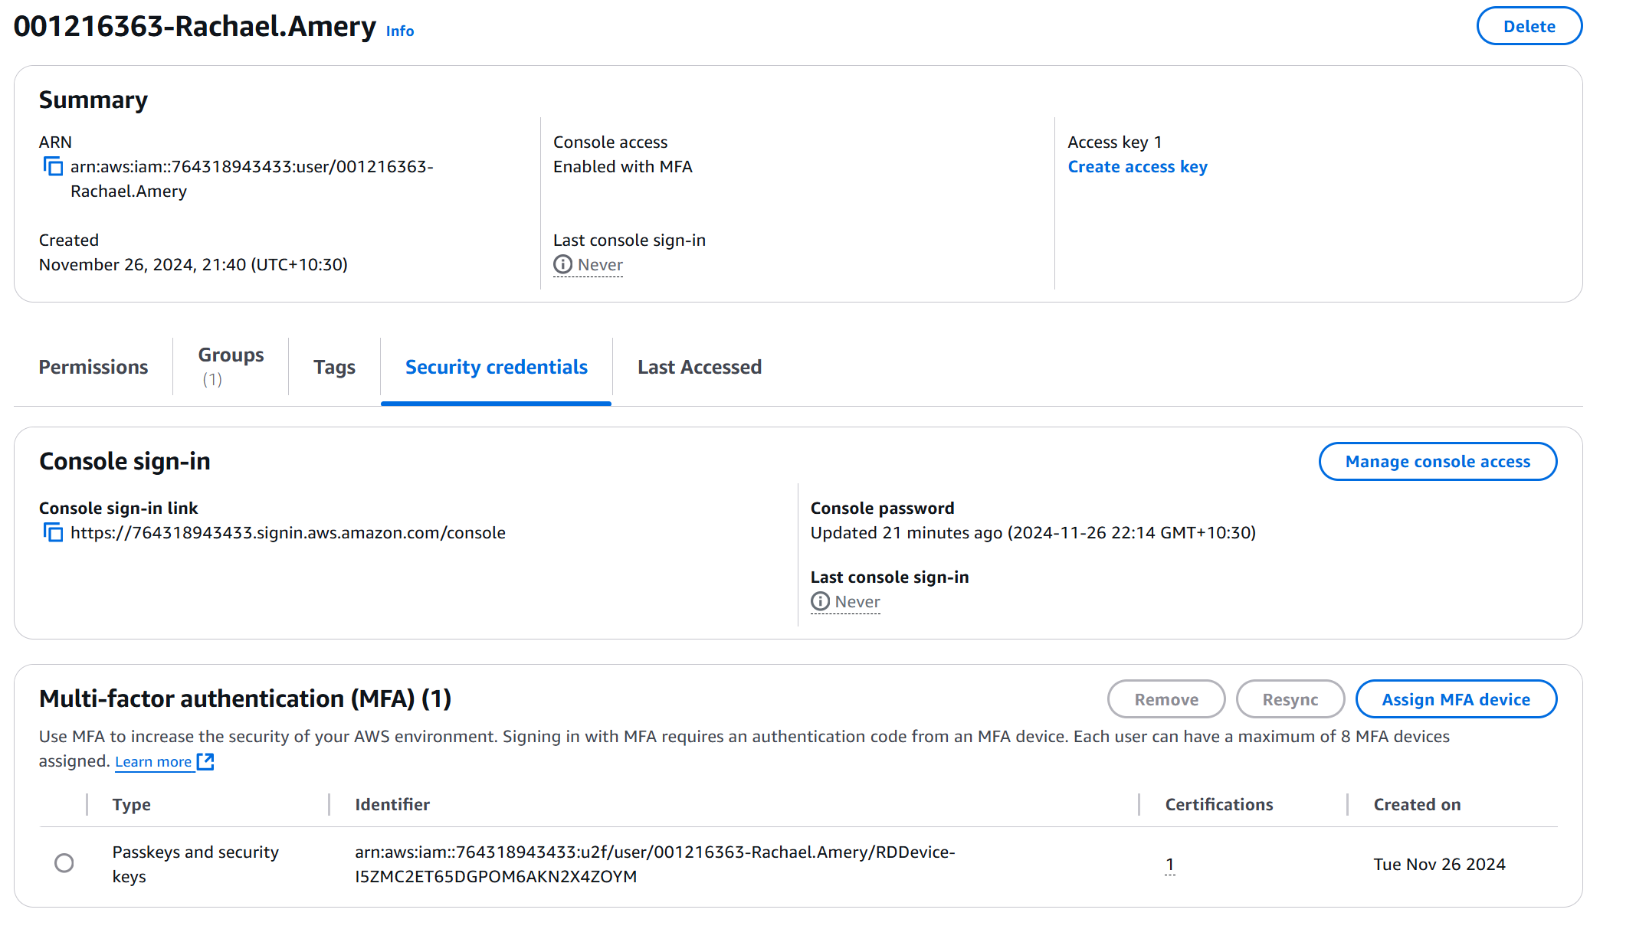

## 2.6 Command-line access to the cloud account.

*…screenshots of the AWS command Tool to list all your created users …*

# 3. Create AWS Virtual Network and Security settings

## 3.1 Configuration of multi-tiered virtual network

|  |  |  |  |  |
| --- | --- | --- | --- | --- |
| Subnet Name | IP Address Range | Availability Zone | Routing Table | Routing Table Record |
| *ErfylVPC Name?* | 10.**27**.0.0/16 | N/A | N/A | N/A |
| *Public Subnet 1 Name?* | 10.**27**.1.0/24 | *us-east-1a* | *Public Route table* | *rtb-0aebf2fb5e15dc4b0* |
| *Private Subnet 1 Name?* | 10.**27**.2.0/24 | *us-east-1a* | *Private Route table* | *rtb-044738331efe288f7* |
| *Public Subnet 2 Name?* | 10.**27**.3.0/24 | *us-east-1b* | *Public Route table* | *rtb-0aebf2fb5e15dc4b0* |
| *Private Subnet 2 Name?* | 10.**27**.4.0/24 | *us-east-1b* | *Private Route table* | *rtb-044738331efe288f7* |

|  |  |  |
| --- | --- | --- |
| Security Group Name | VPC ID | VPC Name |
| TG@ErfylSecurity | sg-041b6464c5884af42 | TG@ErfylVPC |

|  |  |  |  |  |
| --- | --- | --- | --- | --- |
| Inbound Policy Name/ID | Type | Protocol | Port range | Source |
| sgr-0a9e6821ef5d90bdd | HTTP | TCP | 80 | 0.0.0.0/0 |
| sgr-0a04045f3b6e30290 | HTTPS | TCP | 443 | 0.0.0.0/0 |
| sgr-0dc3f7a165a747c63 | SSH | TCP | 22 | 210.185.125.219/32 |

|  |  |  |  |  |
| --- | --- | --- | --- | --- |
| Outbound Policy Name/ID | Type | Protocol | Port range | Destination |
| sgr-0074f7d74ee1994dd | All Traffic | All | All | Anywhere |

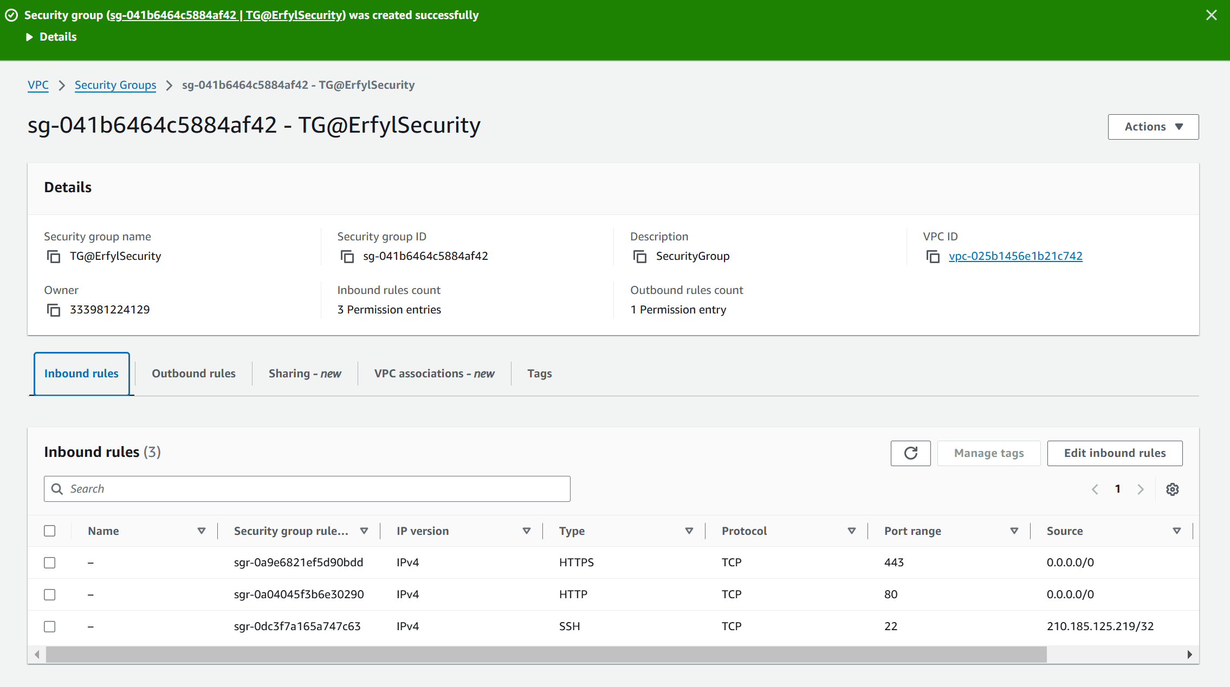

## 3.2 Create virtual machines:

|  |  |  |  |  |
| --- | --- | --- | --- | --- |
| EC2 Server Name | Availability Zone | Applied Security Group | Public IP address | Test Web HTTP result from your machine |
| TG@ErfylServer | us-east-1b | TG@ErfylSecurity | 44.201.219.177 | S*uccess*  *Not success* |

## 3.3 Storage Configuration:

|  |  |  |  |  |
| --- | --- | --- | --- | --- |
| EBS Volume Name | Volume ID | Original Size | Availability Zone | Device Name after Attach to EC2 |
| TG@Volume | vol-0bcff5694791ea025 | 1 GiB | us-east-1b | */dev/sdb* |

Update the storage size, resize and show the updated size in the system.

|  |  |  |  |  |
| --- | --- | --- | --- | --- |
| EBS Volume Name | Volume ID | Updated Size | Availability Zone | Device Name after Attach to EC2 |
| TG@ErfylVolume | vol-0bcff5694791ea025 | 10 GiB | us-east-1b | */dev/sdb* |

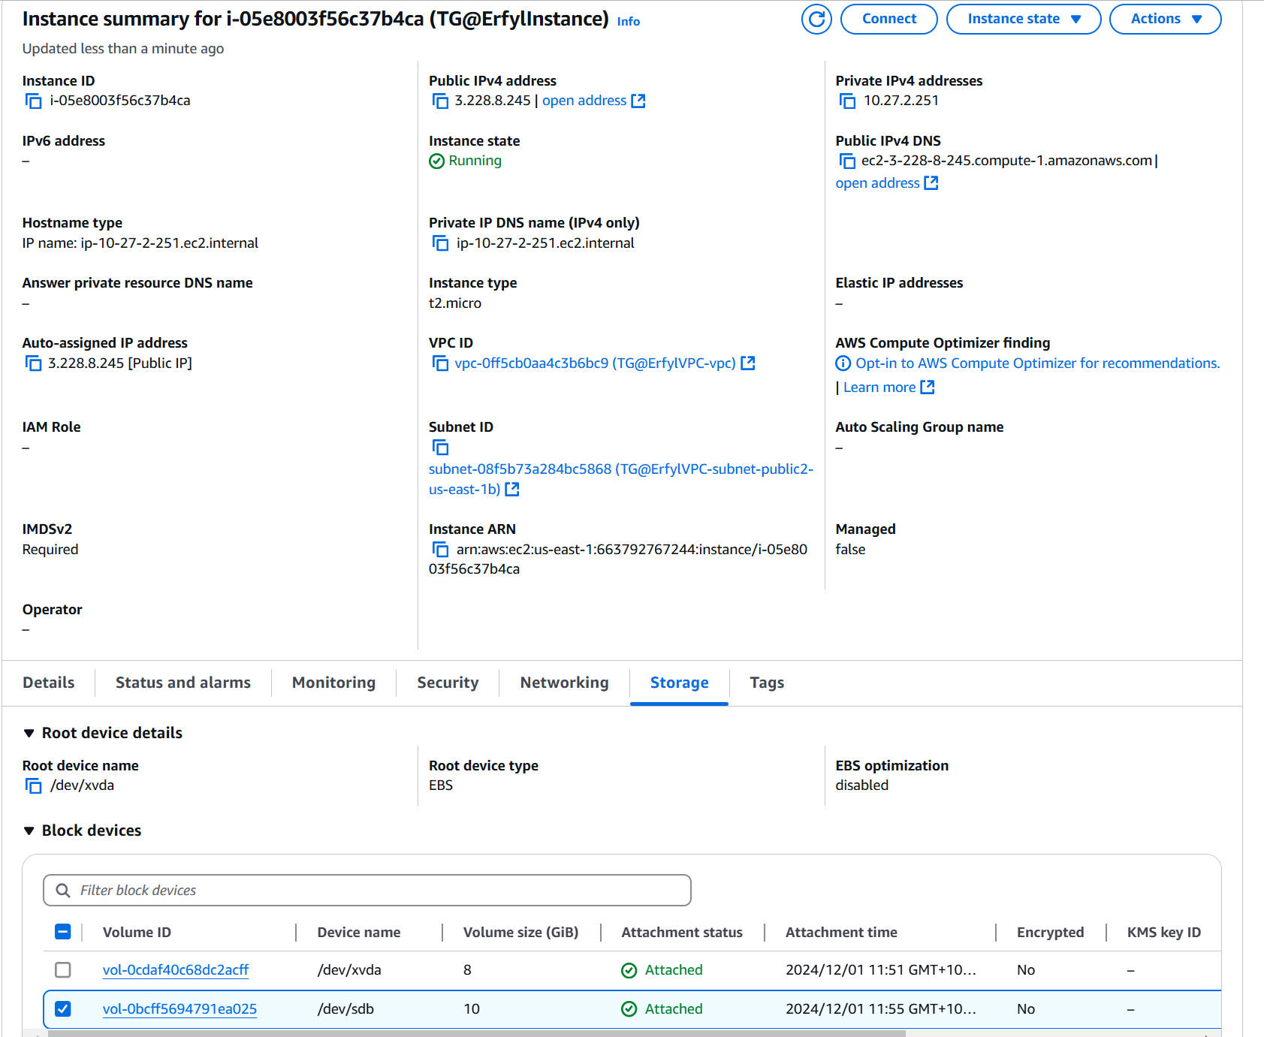

## 3.4 Database Configuration:

|  |  |  |  |  |  |  |
| --- | --- | --- | --- | --- | --- | --- |
| Database Engine | DB instance Name | DB Name | Availability Zone | Multi-AZ enable | Secondary Zone | Retention Period Days |
| MySQL | ErfylDatabase | Erfyldatabase | us-east-1b | *Yes* | *Us-east-1c* | *14 days* |

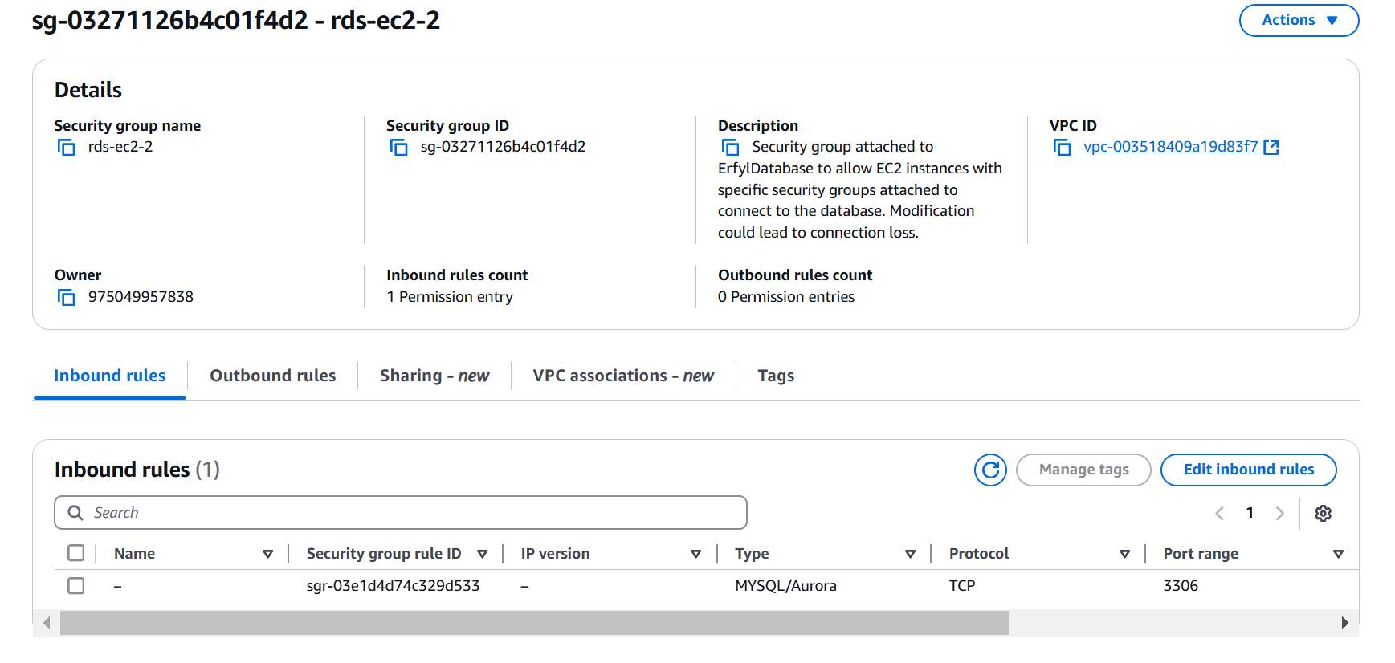

EC2 server connects to database screenshot:

# 4. Auto-Scaling Configuration and Troubleshooting

## 4.1 Auto-Scaling Configuration

|  |  |  |  |  |  |  |
| --- | --- | --- | --- | --- | --- | --- |
| AMI - ID | Launch template Name | Load-balancer URL | Desired capacity | Minimum Capacity | Maximum Capacity | Scaling Condition |
| [ami-0830ed32988c95eeb](https://us-east-1.console.aws.amazon.com/ec2/home?region=us-east-1#ImageDetails:imageId=ami-0830ed32988c95eeb) | TG-ErfysLaunchTemplate | [lt-0623dbc1dc266c03c](https://us-east-1.console.aws.amazon.com/ec2/home?region=us-east-1#LaunchTemplateDetails:launchTemplateId=lt-0623dbc1dc266c03c) | 2 | *2* | *5* | *As needed to keep the average CPU utilization at 60%.* |

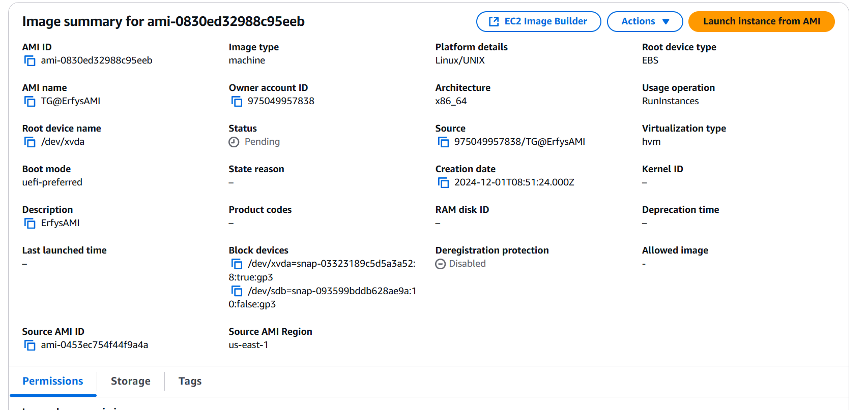

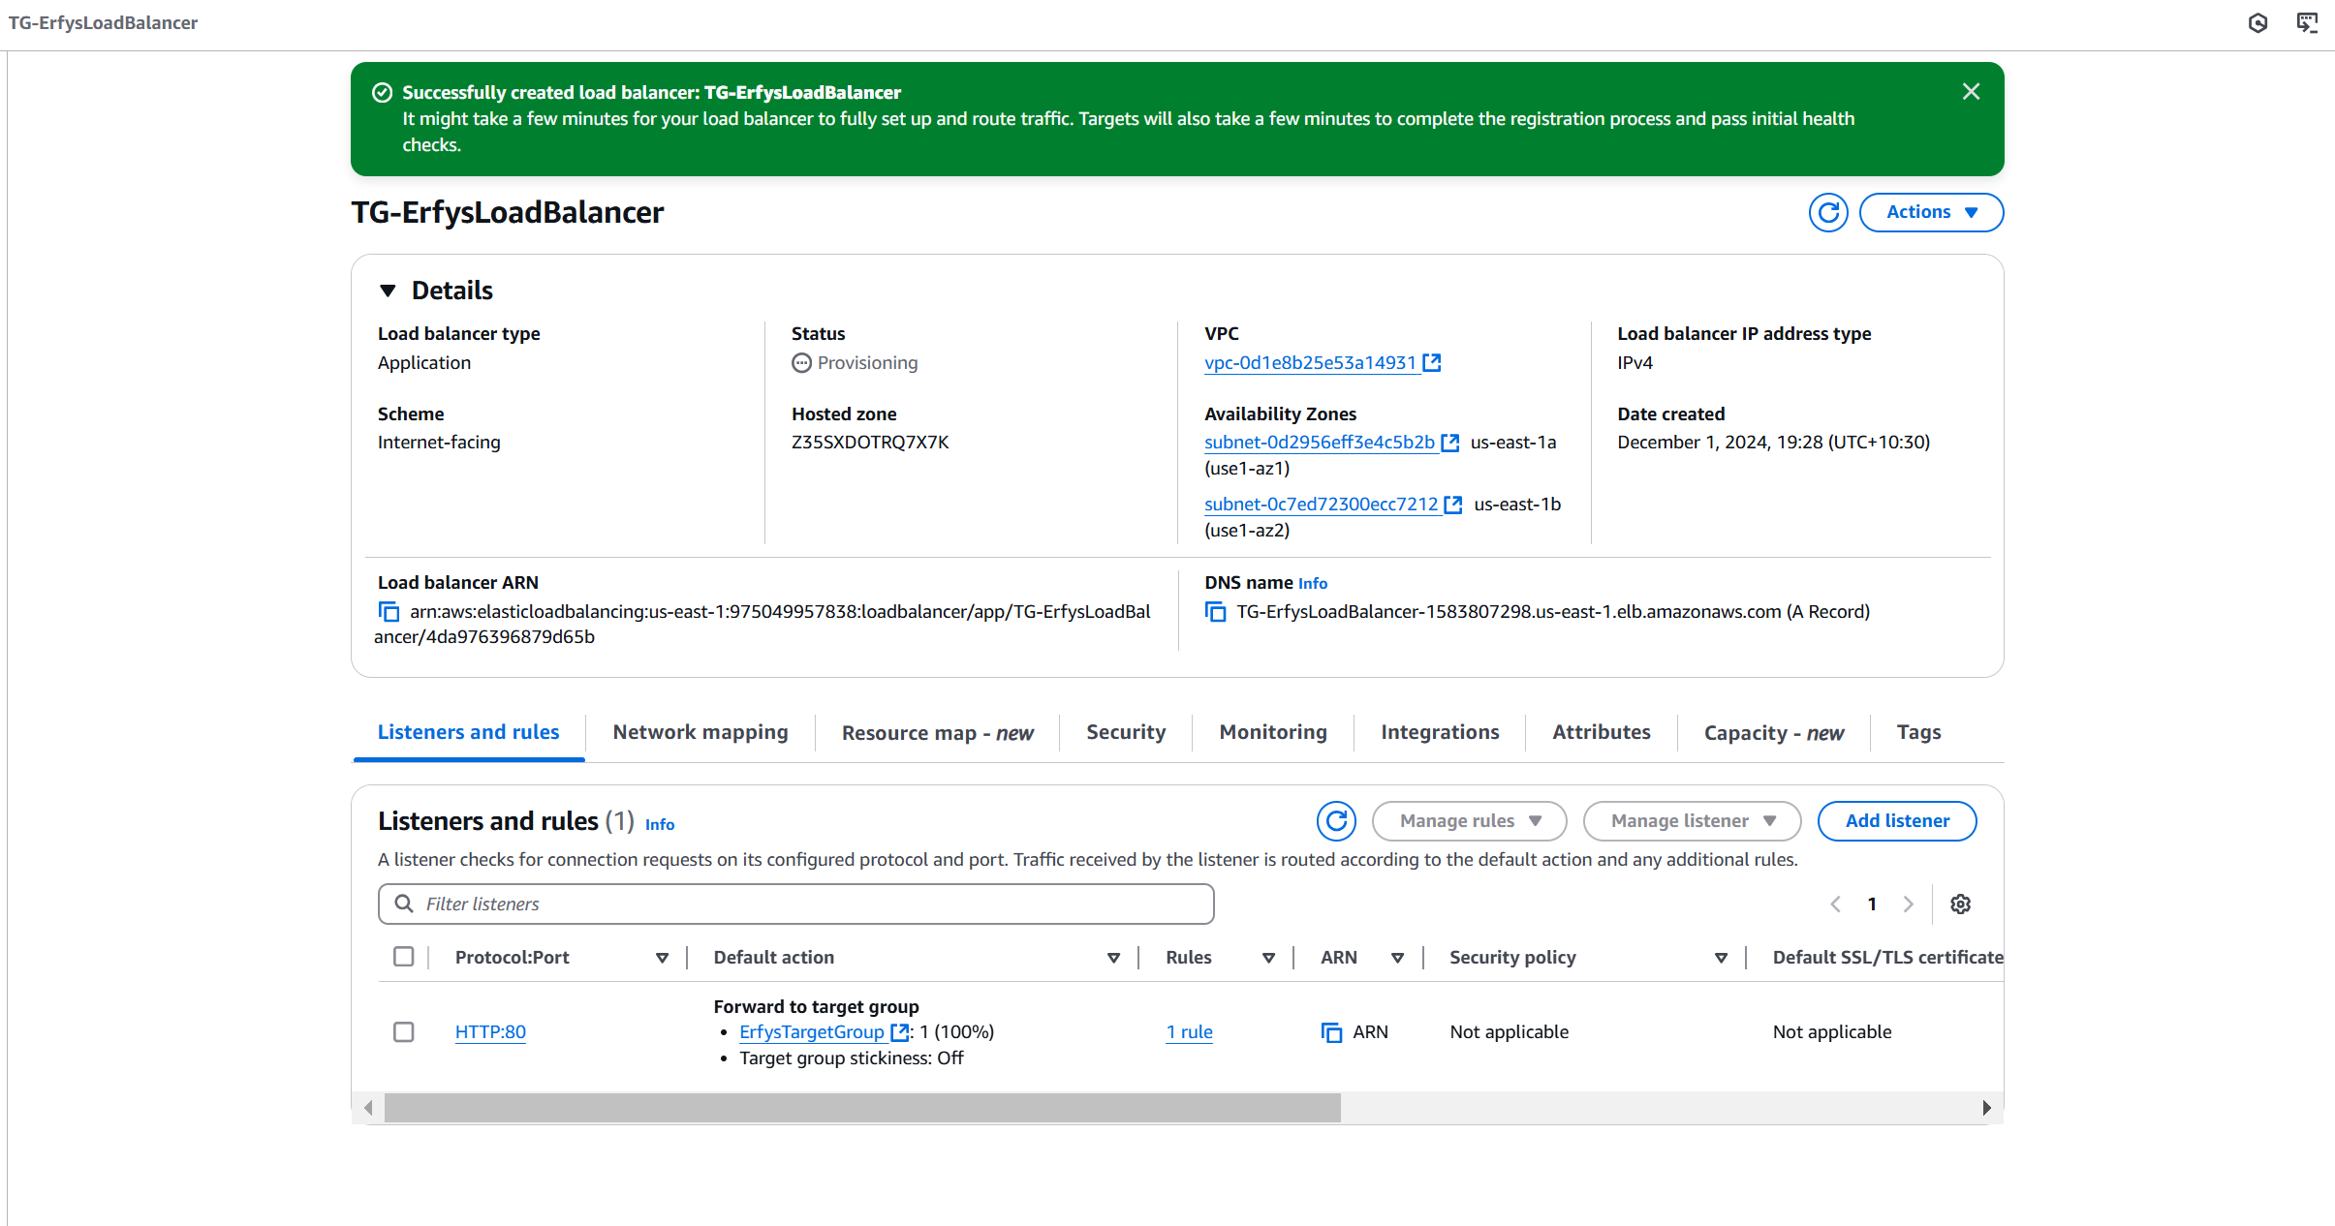

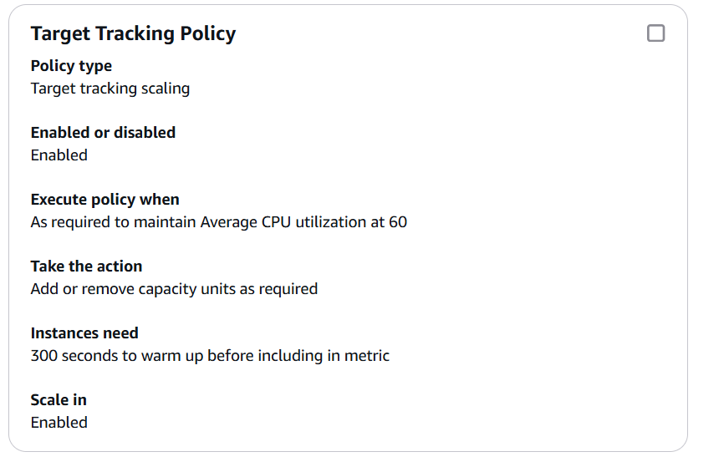

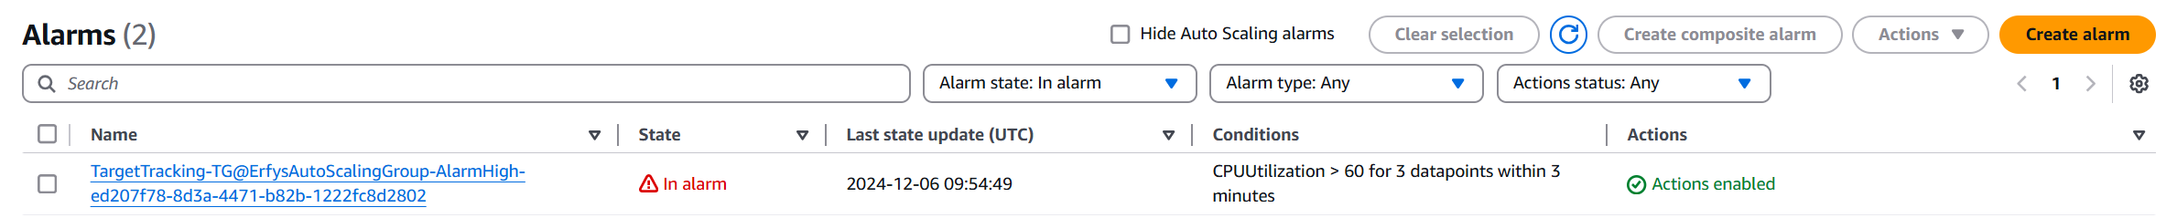

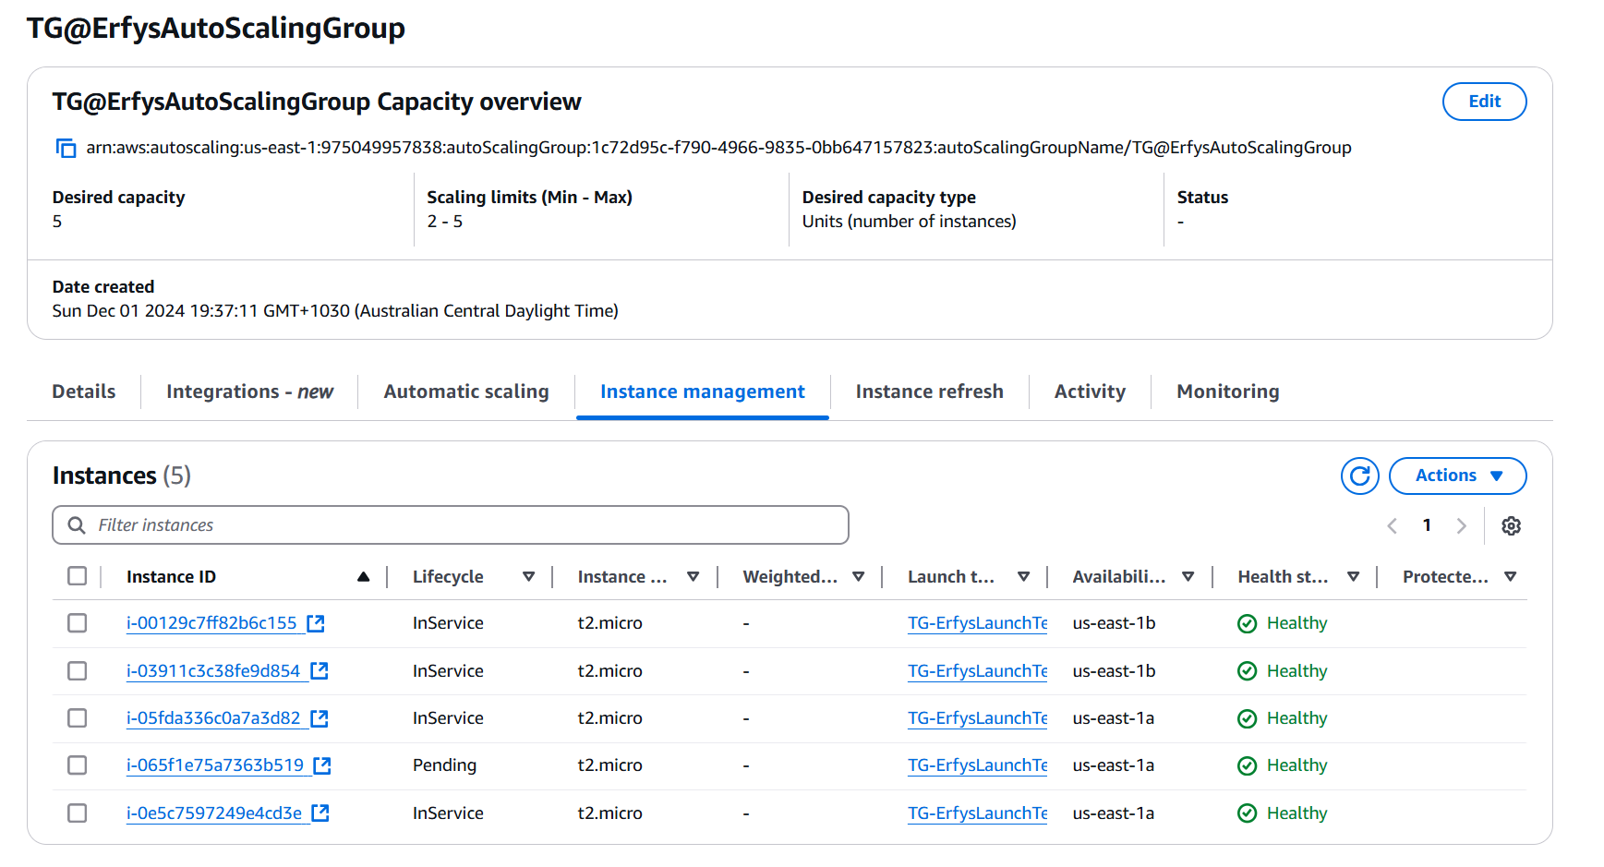

## 4.2 Troubleshooting Task

|  |  |  |
| --- | --- | --- |
| Problems | Description (Cause) | Fix solution |
| 1. Cannot access HTTP server (2 problems) | 1. Security Group missing HTTP (Port 80) rule.  2. Route table missing route to the Internet Gateway. | 1. Add an inbound rule for HTTP in the security group.  2. Update route table to include 0.0.0.0/0 to IGW. |
| 1. Autoscaling not working properly (2 problems) | 1. Autoscaling had incorrect a minimum desired 2 instances, and maximum instances  2. No autoscaling policy that adjusts at 9:00-11:00 AM daily. | 1. updated autoscaling with a minimum of 1 instance, desired 2 instances, and a maximum of 3 instances.  2. updated autoscaling policy to adjusts to a minimum of 2 instances, desired 3 instances, and a maximum of 4 instances at 9:00-11:00 AM daily. |

Provide Fix screenshots:

Problem 2-2: 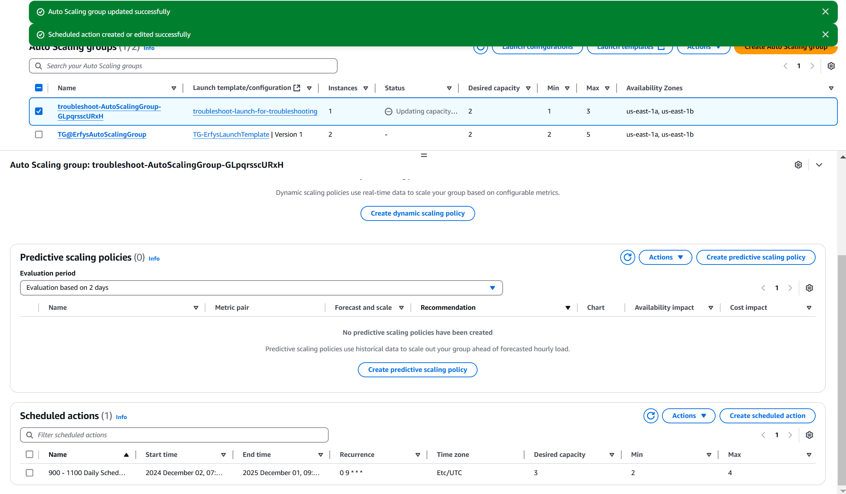

# 5. Documentation and seeking feedback

## 5.1 Troubleshooting Task

Use the below template to create user documentation with instructions on how to create a new EC2 instance.



## 5.2 Seeking Feedback

## Compose an email to the ITWorks manager.

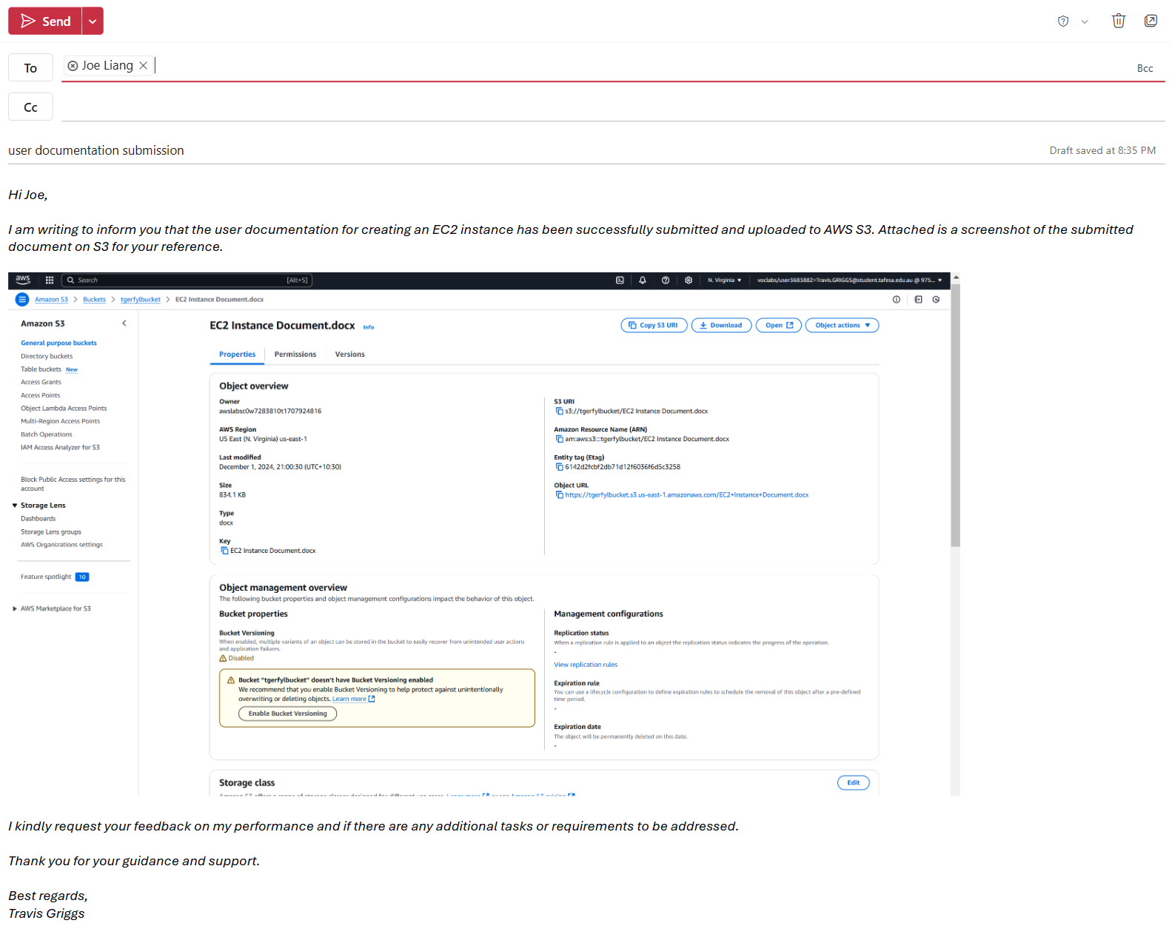

# 6. Retrieved feedback and finish the additional task

Task URL and required screenshot(s)

*…screenshot(s)* *of task 6 (Using Task 3-2 EC2 Web App S3 tab link to verify).…*

Email draft in response.

*…screenshot(s)* *of email draft.…*